Orange County Transportation Authority
Long-Range Transportation Plan
NIXEL Eblast

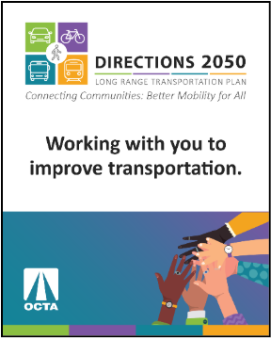
Image Sample:

Provide your input! Take the OCTA survey and attend our upcoming meeting.

The Orange County Transportation Authority (OCTA) would like to get your input to guide planning for future improvements to the County’s transportation system. There are multiple ways to get involved and share your opinion:

- Online Survey: Take the survey by November 9th for a chance to win one of four $50 gift cards!
- Zoom Webinar: Join the conversation on Wednesday, October 8, 2025 at 6:00 PM. Register today!
- Follow & Comment: Sign-up for meeting reminders and comment on the plan.
- Hotline: Call (800) 719-0037 to ask questions and leave comments.

Learn more about the plan at www.OCTA.net/LRTP.

