Orange County Transportation Authority
Long-Range Transportation Plan
Eblast/Newsletter

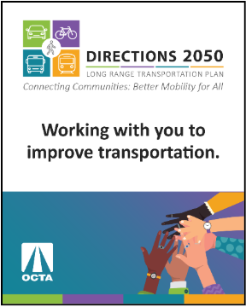
Image Sample:

Subject: Get involved and let OCTA know your mobility needs.

Body:

Provide your input! Take an OCTA survey and attend the upcoming community webinar.
The Orange County Transportation Authority (OCTA) is updating the Long-Range Transportation Plan (LRTP), which outlines priorities for transportation improvements in Orange County over the next 20+ years. Your input is key to making sure the plan reflects community needs and priorities. Here are a few ways to get involved:

- Online Survey
Take the survey by November 9th for a chance to win one of four $50 gift cards!
- Zoom Webinar
Join the conversation on Wednesday, October 8th at 6:00pm. Register today!
- Follow & Comment
Sign-up for meeting reminders and comment on the draft plan.
- Hotline
Call (800) 719-0037 to ask questions and leave comments.

Learn more about the plan at octa.net/LRTP.

