Eblast/Newspaper Article & Nextdoor/Neighborhood Blog/Nixel Messaging

Sample email header Image:
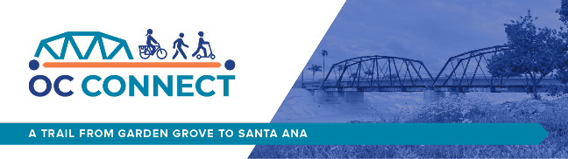

For use any time before Oct 2nd:

Title: Help OCTA improve transportation connections in Garden Grove and Santa Ana!

Body:
OCTA is studying the development of a 4-mile biking and walking trail connection along the former Pacific Electric Right-of-Way (PE ROW) corridor in Garden Grove and Santa Ana. Be part of the visioning process by providing your input at a community meeting or by taking an online survey!

Here is how to get involved:

Attend the In-Person Meeting
Wednesday, October 2, from 6 to 8 p.m.
Vista Heritage Global Academy
2609 W 5th St, Santa Ana, CA 92703

Attend the Virtual Community Webinar
Wednesday, October 9, from 6 to 7 p.m.
Webinar ID: 848 2178 2405
Call-in: +1 (213) 338-8477
Register here!

Spanish Call-in Line: 1 (224) 501-3412
Access code: 395-442-525

Participate in the Online Survey
Take the survey by October 31st for a chance to win one of two $50 gift cards!

Learn more about the plan and how you can get involved by visiting occonnect-storymap.com

