Orange County Transportation Authority
Long-Range Transportation Plan
Website Post & Calendar

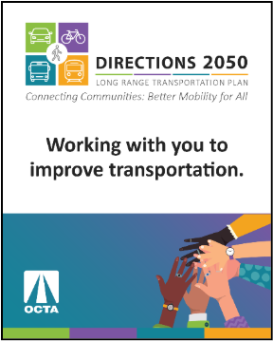
Image Sample:

Learn more about how the OCTA Long-Range Transportation Plan (LRTP) addresses Orange County’s future transportation demands at octa.net/LRTP. Share your input by joining the LRTP webinar on October 8 at 6:00 p.m. and by completing the survey by November 9 for a chance to win one of four $50 gift cards. Sign-up today to receive project updates and meeting reminders.

CALENDAR DATES:
- OCTA LRTP Zoom Webinar | 5:30 p.m. (Register)

