Orange County Transportation Authority
Long-Range Transportation Plan
Nextdoor Blog

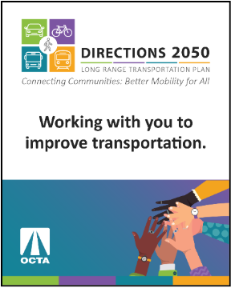
Image Sample:

Text Option 1 – For use any time before 10/8/25:

Title: Help shape Orange County’s transportation future.

Body:
Join OCTA for the Long-Range Transportation Plan (LRTP) Zoom webinar (10/8 @ 6:00 p.m.) to offer your thoughts on how to improve the future of transportation in Orange County. Visit octa.net/LRTP to learn more. Share the meetings with your family, friends and coworkers.
If you haven’t already, complete the LRTP-Survey.com to be entered into a drawing for a chance to win one of four $50 gift cards, and help shape what’s next. plan the direction forward!

Text Option 2 – For use any time before 11/9/25:

Title: Share your input on the future of transportation in Orange County.

Body:
There’s still time to complete OCTA’s Long Range Transportation Plan (LRTP) survey and make your voice heard. Submit your feedback by November 9 at LRTP-Survey.com for a chance to win one of four $50 gift cards.
Learn more about the plan and how it will guide transportation improvements for the next 20 years at o﻿cta.net/LRTP. Don’t miss this chance to help shape Orange County’s future.

